SURVIVAL OR EXTINCTION

by
KEVIN MUGUR GALALAE

PART EIGHT
BURDEN OF RESPONSIBILITY
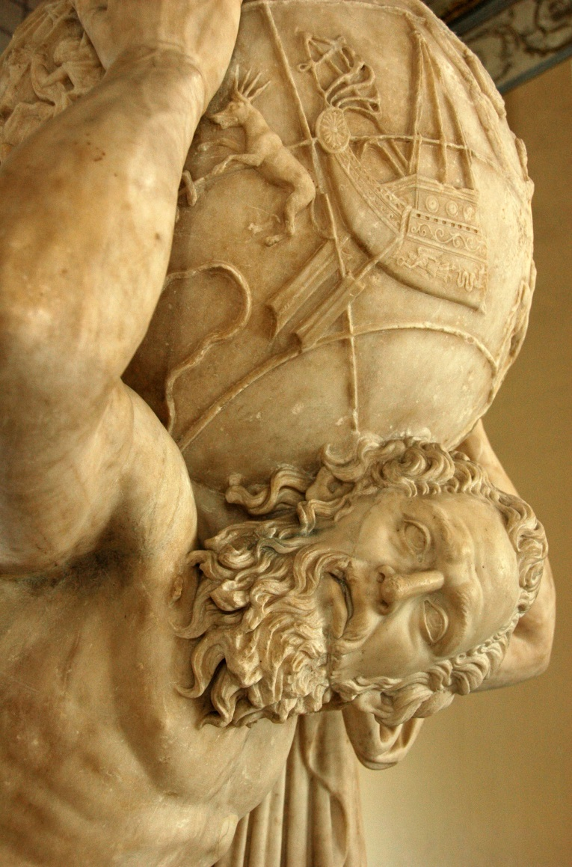

(PART ONE: LIFE OR DEATH; PART TWO: FOLLOW THE MONEY; PART THREE: NEED NOT GREED; PART FOUR: TAMING THE WOLVES; PART FIVE: DISCARD ME NOT; PART SIX: HEAD AND HAND; PART SEVEN: POWER OF MONEY)

This is an article everyone will hate but no one will be able to ignore.
In reading my previous seven articles in this series you have learned that the international community has pursued peace and prosperity since 1945 via three complementary and inseparable fronts: economic integration, political centralization, and population control. Each front has required and continues to require tremendous sacrifices, harsh persuasion, and strict discipline within the ranks of the initiated, which is why the masses have been left out of the equation, democratic processes have been bypassed, deception and propaganda are used to keep the common man in complete ignorance of the facts, and chemical and biological means are employed covertly to create a state of artificial obedience to cheat us of free will and deprive us of our rights and liberties with little or no resistance.
This state of the world was foreseen well in advance. Aldous Huxley spoke these prescient words in 1961:
“There will be in the next generation or so a pharmacological method of making people love their servitude and producing dictatorship without tears so to speak. Producing a kind of painless concentration camp for entire societies so that people will in fact have their liberties taken away from them, but will rather enjoy it, because they will be distracted from any desire to rebel by propaganda, or brainwashing enhanced by pharmacological methods. And this seems to be the final revolution.”
The price of peace and prosperity in the era of consensus forged through the United Nations since World War II has been unimaginably high but well concealed. It has not been, however, as high as that paid by previous generations in the era of armed conflict and the bloodbaths of the two world wars. As such, it is an improvement and this we must celebrate but not to the extent that we declare the end of history and the end of our evolution.
Monetary coercion assisted by covert chemical poisoning at sub-lethal levels has forged a kinder and gentler world in the second half of the 20th century compared to the brute military force and wanton violence of the first half of the century. But it has also produced a western world inhabited by zombies; enfeebled human beings whose intellectual and genetic endowments have been severely degraded and who, as such, are not in control of either their minds or their bodies and who now need to be rescued by outsiders, by their brothers and sisters from the non-western world who have been protected by poverty from the destruction self-visited upon westerners by covert chemical, biological, bacteriological, psychosocial and economic means.
As we save them from poverty, they will have to save us from self-destruction since we have come to love our wealth, technology and self-spun illusions more than we love ourselves, the truth, and our dignity as human beings. That is so because the damage we have done to ourselves is moral as well as physical, having had to invent far-fetched justifications for our foibles and failures and having had to submit our individuality to the soul-killing rationale and giant hierarchies of insensate bureaucracies and institutions that require centralized and global control.
In the previous seven articles I have concentrated on the economic features and machinations of the New World Order. In this and the next five articles I will focus on the political life and features of the modern era.
Let me start by asking what happened to democracy? And why is this new form of tyranny we now live in and that is growing by leaps and bounds emanating from the land of the free, from the democracy of democracies, from a government of the people, by the people and for the people? The answer to this unpalatable question is this: having assumed responsibility for the world the United States has been steadily crushed by the unbearable burden of having to forge unity out of discord and act as the arbiter of peace and the finder of solutions for nearly 200 nations, each with its own worldview, values, norms, culture, interests and system.
The United States has had to be the stick to the carrot that the United Nations represents. America has had to act as the firm father to 200 unruly children, the world’s nation states, while the United Nations has been their mother. America has grown weary and bitter just as a father with 200 brats would after shouldering all the responsibilities for 68 years with little or no help from the relatives.
The children have grown up and want to inherit the world from an America that has grown old and weary. But the children know not the responsibility demanded by the inheritance they are about to receive. And America doubts the children will not tear each other’s throats out to get more than their share and take from their siblings what they are not entitled to when the world ceases to have a firm father with a hard rod and no hesitation to use it.
America, the father of the world post-World War II, is about to expire. The United Nations, the mother of the world will be left alone. But will the mother be able to keep her children in line and preserve peace in a world of equals? Will the education of the children suffice to ensure their good behavior absent a father with a firm rod? Will the rules that have been set in place be sufficiently strong to keep all 200 siblings in line? Have the world’s 200 children grown to love and respect each other to such an extent as to keep the peace in adulthood and share and manage the bounty of the earth without squabbling?
These are open questions that only the future can answer but for which we must prepare and that is exactly what is happening. America’s uncles, the world’s military forces and intelligence agencies, are preparing for the greatest transition of power in history; the transition of authority from the United States, the world’s father, to the United Nations, the world’s mother, and thus from national assemblies to a global government. This political power transfer is occurring in parallel with an economic transfer of equal significance, whereby the 200 siblings have to give up their individual farms and merge into a giant collective estate that they will be asked to manage collaboratively to ensure that their offspring have the same standard of living and that there is no reason to fight among themselves for resources. This concomitant economic transfer is overseen by a different set of America’s uncles, the world’s transnational corporations.
By this process a family will have been forged from 200 reluctant and mutually suspicious strangers. Henceforth, it is hoped, this family will eat at the same table and run the world peacefully. This transformation has been seven decades in the making. It is hoped that the family will hold and become inseparable. It is hoped that the bonds of kinship forged by mutual economic interests and common sacrifices will make the family grow closer and stronger with every generation. No one can argue that this is not a noble goal. Nor can one argue that this is not the only intelligent way to advance human civilization and safeguard peace and prosperity in a world with limited resources and ever-growing demands upon these resources by our kind’s ever-increasing numbers and needs.
Anyone who puts old loyalties and festering prejudices ahead of this goal – be they of a religious, ethnic, or ideological nature – is myopic and an impediment to peace and to the survival of the species and the planet. By the same token, anyone who treats human beings as disposable objects in the pursuit of this noble goal – be it for reasons of economic self-interest, intellectual arrogance, or political expediency – is criminal and an impediment to peace and to the survival of the species and the planet. The common man, by and large, is guilty of ignorance while the elites, by and large, are guilty of cruelty and, as such, we are each other’s impediments to peace and obstacles to progress in the grand and beautiful design to rescue our species, our civilization, and our planet from the destructive ways of man and the ignorance of mankind.
This being the case, a new socio-political entity is needed to educate the common man and restrain the elites so that we can all act as assets and not as liabilities in the pursuit of the noble goal and existential necessity that global unity represents. I call this new entity the Center of Global Consciousness and birthed it in body and spirit, have rooted it in knowledge and truth, and nourish it from the fountain of the universal subconscious. Its purpose is to help humanity rise to a higher level of existence, but because it must forge ahead of everyone else it cannot be democratic, as much as I want it to be.
And that is the dilemma of leadership and the shortcoming of democracy. Democracy cannot provide leadership when it matters most and when it is needed most, at those times in history when we have to break the mold and reinvent the wheel. This I have come to know the hard way, through bitter experience; the disappointment, the heartbreaking disappointment, of trying and failing to move the masses so we can walk into the future shoulder to shoulder, as equals. I concede that I was wrong to believe that I could move the masses and that the elites were right to forge ahead without us.
The Council on Foreign Relations (founded in 1921), the Bilderberg Group (1954), the Club of Rome (1968), the Trilateral Commission (1973), the so-called Illuminati institutions, as well as the United Nations, were created to forge ahead and they did. They did so with extraordinary resolve and frightening cruelty but had they adopted a laissez-faire attitude and waited for the world’s elected assemblies to act, the world would have long burned to ashes and absolutely nothing would have been accomplished.
To achieve the political centralization needed to move the world’s 200 unruly children in tandem towards a common future, a process that is still ongoing and is by no means complete, has required divesting national assemblies of power and investing international organizations with the authority to pull the strings from behind the scenes and above the heads of national parliaments.
It is out of dire necessity that democracy has been replaced with plutocracy and in the process the rule of the people has been displaced by the rule of a dominant minority. Voters simply lack the foresight to think let alone act with objectives in mind that are a century away and on which the survival of the species depends. Elected assemblies are forced to cater to the will of the people and the will of the people never translates into more than immediate gratification. The pigs will fly before voters demand to make sacrifices for generations yet unborn or for people at the other end of the world, which is what globalization and its underbelly, depopulation, are seeking to achieve. The reality is that nowhere in the world are voters so decent, selfless, informed and astute as to demand from their politicians the pursuit of objectives not for their own benefit.
This may sound harsh and many will object by crowing that we are simply not given the necessary information, education and incentives to think that far ahead and in global terms. But that is just a poor excuse and I put it to the test by giving people the truth and nothing but, and forming a political party whose manifesto considers future generations, the global common, and all people on earth with the same concern as the needs of living voters in our fine liberal democracies.
Low and behold most people find the truth so offensive that they would rather decapitate the messenger than consider its harsh realities, which is why my books on the global depopulation policy have been received by the vast majority with such deep contempt towards me that were they to act upon it I would long have been hanged, drawn and quartered by a blood-thirsty mob of good Christian folks.
Low and behold, the party I formed, the Human Rights Party of Canada, as well as its manifesto, have attracted no more than a handful of members, despite the high ideals they represent and the alternative solution they offer to the current globalization/depopulation New World Order. The low level of education of the average man and woman, the abysmal lack of understanding of global matters, and the self-centeredness and shallowness of most people ensure that no political party, however well-funded and well-intentioned, would ever come to power if it advocates anything other than the most basic and base demands of voters. That is why a shadow government exists and thank God it does!
The only caveat I make to this remark is that my fellow Canadians, as all westerners, have been brainwashed by sophisticated propaganda and their minds adulterated by chemical poisons for nearly seven decades and, as such, they are but shadows of their former selves and in control of neither their minds nor their bodies, and certainly not of their destinies, political or otherwise. But this caveat, strong though it is, does not account for the lack of political self-determination and existential far-sightedness that one sees elsewhere, in nations where the population has not yet been adulterated by covert and immoral means.
And so we come to an impassable dilemma; political centralization is needed now more than ever before if we are to complete the necessary transition from a world organized according to national interests to a world organized around common global interests, but democracy, because it is beholden to nation states, cannot reach the much-needed political centralization. Yet without the political will and the institutional infrastructure to carry out this process there can be no coordinated and peaceful action and humanity will forever remain separated by artificial borders and incapable of solving the material, environmental and political problems that threaten our very existence.
The reality is that the will to accomplish global unity could not have been initiated let alone coordinated by the national assemblies of the world’s 200, or thereabouts, independent nation-states, whose voters are not up to the task and perhaps never will be. Someone had to forge ahead and the elites did.
The best we can hope for now is that we can reach the level of understanding our elites did half a century before us and that we participate in the arduous process of creating a global democracy before the elites kill us all because we are redundant and of no good to the future of the planet; a future in which we have no say and place as it stands.

And so we come to OM Principle 6, the theoretical embodiment of a government that is truly democratic because everyone participates in it. Such a government, however, is not possible in a world of couch potatoes who expect manna from heaven and who live their lives in the thick haze of mind-altering propaganda and drugs.
PRINCIPLE 6
GOVERNMENT OF THE PEOPLE, BY THE PEOPLE AND FOR THE PEOPLE

Politics is too important to be left to politicians. Direct democracy through referenda for the most important decisions and truly representative democracy for daily governance are the answers to today’s state dysfunction and self-serving political class. The political class will be replaced by rotating representatives of the populace elected locally every two years to represent a cross-section of society for one and only one term of office in life. This will free democracies of the tyranny of lawyers and will ensure that government is composed of members of all professions and income groups. It will also prevent the monopolization of political power by the established elite and their manipulation by interest groups.

If there is one thing I have learned during the last five years of trials and tribulations is that I am far more like the illuminati and far less like the people I want to save, but who don’t want to be saved. The former are alive and aware and brave enough to struggle with the world’s problems, while the latter are dazed and confused and too intoxicated with trivial pursuits to want to stare reality in the face.
The elites have assumed the heavy burden of responsibility while the masses have learned to love their servitude.

